**Rajan Gautam**

**19BCP101**

**Div. II, CE 19**

**SOT, PDPU**

**Pandit Deendayal Energy University**

**School of Technology**

**Design Pattern and Thinking (20CP210P)**

**B. Tech - Computer Science & Engineering (Sem-IV)**

**Table of Contents**

**Lab 4 Assignment: Singleton Design Pattern for Car 1**

**AIM: To write a Java Program to implement Singleton Design Pattern for Car 1**

**CODE: 1**

**Rajan_Singleton.java 1**

**Rajan_TestCar.java 1**

**SCREENSHOT OF IDE: 2**

**SCREENSHOT OF OUTPUT: 3**

# Lab 4 Assignment: Singleton Design Pattern for Car

## AIM: To write a Java Program to implement Singleton Design Pattern for Car

## CODE:

### Rajan_Singleton.java

1. **package Singleton_19BCP101_Rajan;**
3. **public class Rajan_Singleton {**
4. **public static Rajan_Singleton rajanInstance = new Rajan_Singleton();**
5. **public int i;**
6. **private Rajan_Singleton()**
7. **{**
8. **System.out.println("Car Created...");**
9. **}**
11. **public static Rajan_Singleton getInstance()**
12. **{**
13. **return rajanInstance;**
14. **}**
15. **public int getI()**
16. **{**
17. **return i;**
18. **}**
19. **public static void setRajanInstance(Rajan_Singleton rajanInstance)**
20. **{**
21. **Rajan_Singleton.rajanInstance = rajanInstance;**
22. **}**
23. **public void setI(int i)**
24. **{**
25. **this.i = i;**
26. **}**
27. **}**

### Rajan_TestCar.java

1. **package Singleton_19BCP101_Rajan;**
3. **public class Rajan_TestCar {**
4. **public static void main (String args[])**
5. **{**
6. **Rajan_Singleton rajan_car1 = Rajan_Singleton.getInstance();**
7. **Rajan_Singleton rajan_car2 = Rajan_Singleton.getInstance();**
8. **Rajan_Singleton rajan_car3 = Rajan_Singleton.getInstance();**
10. **rajan_car1.setI(54);**
11. **rajan_car2.setI(82); // It overrides the value 54.**
13. **System.out.println("Speed: " + rajan_car1.getI());**
14. **System.out.println("Speed: " + rajan_car2.getI());**
16. **print("My Bugatti", rajan_car1);**
17. **print("My Lamborghini", rajan_car2);**
18. **print("My Mercedes", rajan_car3);**
19. **}**
21. **static void print(String rajan_carName, Rajan_Singleton rajan_obj)**
22. **{**
23. **System.out.println(String.format("My Car : %s, HashCode : %d", rajan_carName, rajan_obj.hashCode()));**
24. **}**
25. **}**

## SCREENSHOT OF IDE:

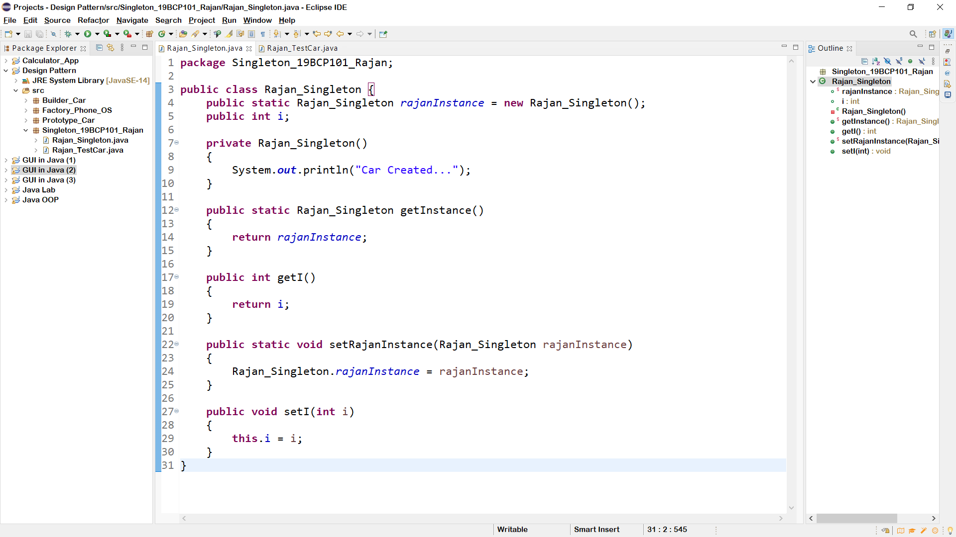

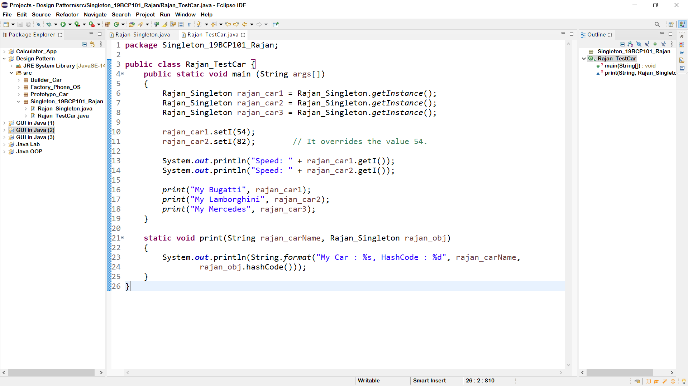

## SCREENSHOT OF OUTPUT:

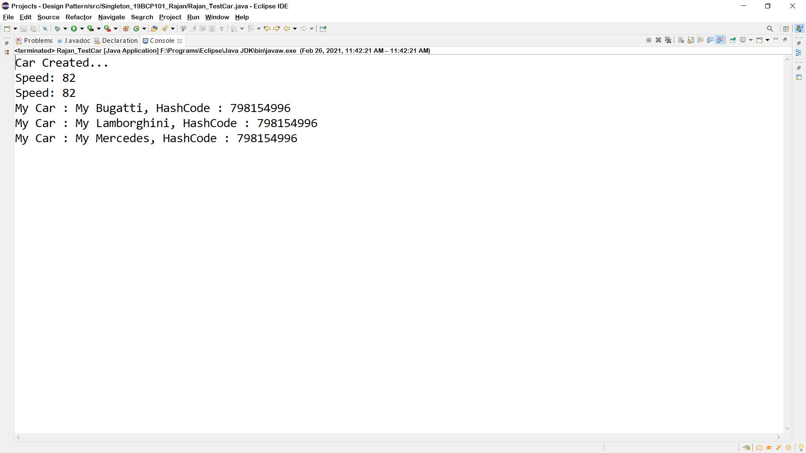

**GitHub Link:** [**https://github.com/rgautam320/Design-Pattern-Lab/tree/main/Singleton_Car**](https://github.com/rgautam320/Design-Pattern-Lab/tree/main/Singleton_Car)